ShipSmart Design Document

**DESIGN DOCUMENTS**

**ShipSmart**

5/21/2021

|  |  |
| --- | --- |
|  |  |
|  |  |

Course: CSIT 515-01: Software engineering & Reliability

Instructor: Dr. Hubert Johnson

By Software Chasers

Heba Shubib

Pragati Gupta

Sagina Athikkal

Tejaswi Kukalakunta

**Table of Contents**

**1. Introduction** 3

**1.1 Project Goals** 3

**1.2 Project Purpose** 3

**1.3 Purpose of current document** 3

**2. ShipSmart System Overview** 3

**2.1 Customer’s view pages** 3

**2.2 Admin’s view** 3

**2.3 ShipSmart Software Use-Case Diagram** 4

**3. ShipSmart Software Class Diagram** 5

**4. Unified Pages Look** 6

**5. Home Page** 7

**6. Sign Up Page** 8

**7. Login Page** 10

**7.1 Customers’ Login/ Sign up Sequence Diagram** 12

**7.2 Employee Login/ Sign Up Sequence Diagram:** 14

**8. Create Shipment** 14

**8.1 Create Tab** 14

**8.2 Package Tab** 16

**8.3 Pay & Print Tab** 18

**8.1. Sequence diagram of Create shipment/ make payment** 21

**9. Track shipment Use Case Definition.** 22

**10. International Shipping Page** 23

**11. Delivery Rates** 24

**12. About US** 25

**13. Contact Us** 25

**14. Admin Dashboard** 26

# **1. Introduction**

## **1.1 Project Goals**

ShipSmart software will be an operation-management tool which will be built to meet industry-specific needs for domestic and cross-border logistics. ‘Software Chasers’ will develop a single system for the company to meet its operations, accounting, visibility and tracking, connectivity and compliance needs. It will also provide a solution to an end-to-end supply chain management for logistics.

## **1.2 Project Purpose**

Software Chasers will develop a system that will help the PATCO Shipping company to manage the company’s shipping operation end to end. This system will help PATCO to attract new clients as well as maintain a good retention rate. The goal of Software Chasers is to create a software for the client.

## **1.3 Purpose of current document**

The purpose of this design document for the ShipSmart system is to include a detailed description of the system look and feel in terms of pages overall look, navigation bars, buttons, and fields in each page in the system. In addition, this document will illustrate how the system’s functionalities and procedures will be designed to achieve the system’s objectives.

# **2. ShipSmart System Overview**

ShipSmart has two different views, one for the customer and one for the admin.

### **2.1 Customer’s view pages**

Customers are allowed to login, signup, book a shipment, schedule pick up for the shipment, explore About_Us and Contact_Us pages. They also can track their shipment any time.

All customer’s pages have the same

1. Navigation bar on the top which allows user to do most of the activities mentioned above.
2. Page footer which includes links for PATCO’s social media platforms.

### **2.2 Admin’s view**

ShipSmart system’s admin has access to the main functions of ShipSmart system:

* Create Shipment.
* View all customers orders.
* Calculate Shipping prices.
* Track Shipments.
* View Billing and audit reports.
* Warehouse Management.
* Create Claims.
* Create Coupons and promo codes.

ShipSmart System has easy access admin dashboard which allow ShipSmart system’s admin to manage all of the above functions

## **2.3 ShipSmart Software Use-Case Diagram**

“Figure 1” use-case diagram illustrates the ShipSmarts’ actors and the functions they will trigger

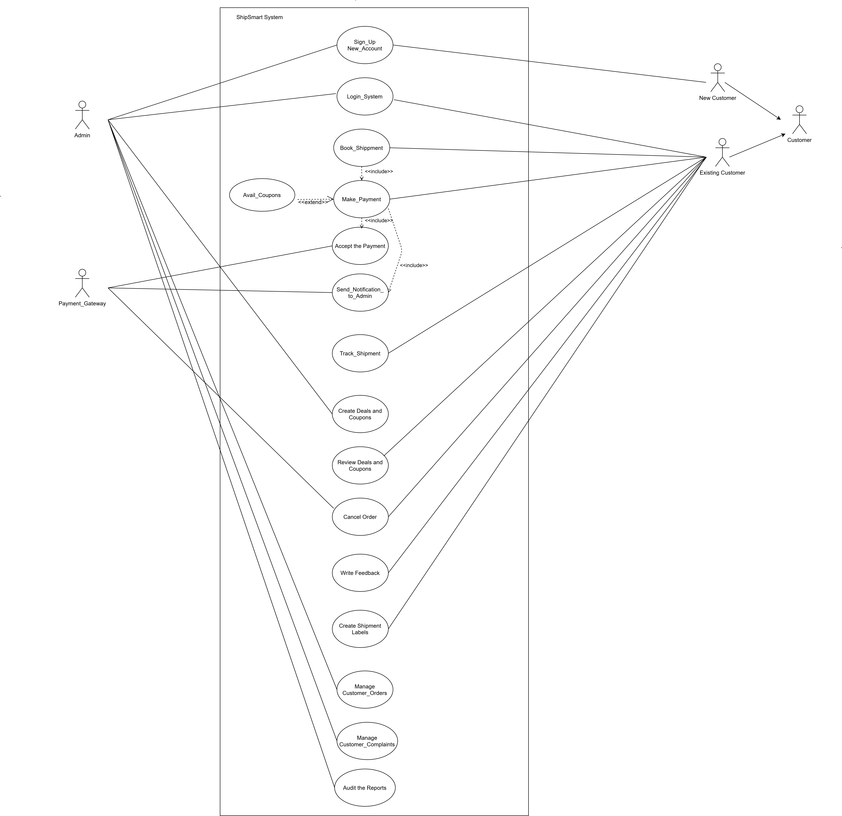

Figure : ShipSmart Use-Case Diagram

# **3.** **ShipSmart Software Class Diagram**

The below “Figure 2” class diagram describes the structure of the ShipSmart and shows the system's classes, their attributes, operations, and the relationships among objects.

***User***

firstName: string

-

lastName: string

-

emailId: string

-

password:string

-

signUpDate: date

-

loginStatus:string

-

+

verifyLogin(): bool

**Customer**

address:string

-

-

phone: int

-

payment info: string

-

shippingInfo: string

()

register

+

()

login

+

updateProfile

+

()

**Admin**

-

employeeId: string

adminEmail: string

-

updateOffers

+

()

()

auditReport

+

+

()

createComplains

**Track Shipment**

trackingId: int

-

+

viewShippingStatus()

**Book Shipment**

addressFrom: string

-

-

addressTo: string

pickupDate: date

-

-

pickupTime: time

-

packageDeatils:string

packageWeight: int

-

+

()

bookShippment

()

selectDeliveryoption

+

+

checkOut

()

+

printLabel

()

cancelShippment

+

()

**Shipping Info**

-

shippingId: int

shippingCost:int

-

-

shippingfrom:string

shippingTo:string

-

()

updateShippingInfo

+

**Payment Info**

-

shippingId: int

shippingOption:string

-

-

weight:int

-

totalCost:float

calcprice

+

()

+

verifyPayment

()

**0..\***

**1**

0..*

1

1

1

1

1

1

1

.

,

Figure : ShipSmart Class Diagram

# **4. Unified Pages Look**

All pages across the ShipSmart Software will have the following in addition to the page’s specified content which will be demonstrated separately for each page:

* **The Header Section** shown in “Figure 3” includes navigation bar that will be the main means to navigate throw the ShipSmart Software and move conveniently from one screen to the other. The navigation bar will be reflected on every page of the system and will be consistent throughout the website pages.

The Navigation Bar will include these tabs:

* 1. Home: directs the user to the homepage screen.
  2. Login/ Sign up: directs the user to login/ sign up screen.
  3. About Us: directs the user to the About Us screen.
  4. Contact Us: directs the user to the contact us screen.
  5. Our Services: this Drop Menu has four options:
     1. Create New Shipment: directs user to the create new shipment screen.
     2. International Shipping: directs user to the international shipping screen.
     3. Rates & Delivery Times: directs user to the rates and delivery times screen.
     4. Schedule a Pickup: directs user to the schedule a pickup screen.

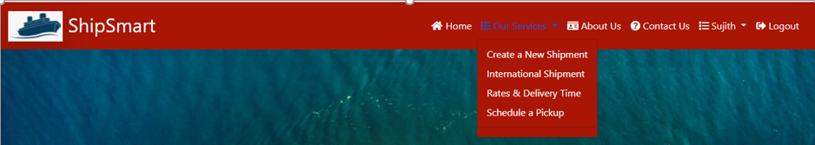

Figure : Header Section

* **The Footer Section** Shown in “Figure 4”: The bottom of each page will be highlighted to represent a separate section and will reflect the following:

1. Social Media image buttons: direct the user to social media platforms screens.
2. Get Free Quotes: leads user to get free quotes screen.

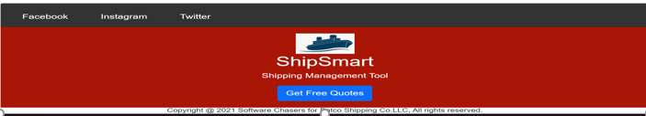

Figure : Footer Section

# **5. Home Page**

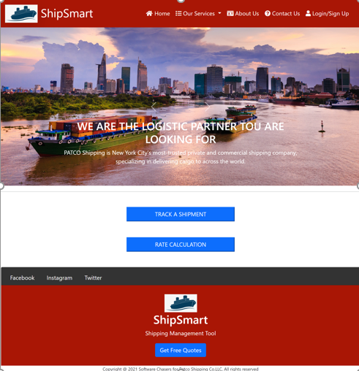

Figure : Home Page

The Homepage, shown in “Figure 5 “, will be the primary access point to the website. Upon clicking/entering the website’s URL, users will be directed to the Homepage. The Home page design will be as follows:

* As of all pages on the ShipSmart software this page must follow the unified pages look specified in section 4. Unified Pages look.
* Between the page header and footer home page include these described below:

1. Slide images: give a brief about Patco Shipping company.
2. Rate Calculation Button: when click will open a small form so user can enter the origin shipment zip code, the destination shipment zip code and the weight of the shipment, then click the calculate button and it will show a message for the user with the estimated price.
3. Track Shipment Button: will open a form for the user to enter the shipment tracking number and a track shipment button which will allow user to track the shipment last checking in point.

# **6. Sign Up Page**

Login Page includes:

* As of all pages on the ShipSmart software this page must follow the unified pages look specified in section 4. Unified Pages look.
* The Sign Up Page will contain the following:
* Sign Up **fields.**
* A **forgot password** check box.
* Between the page header and footer home page includes two options:

1. Customer Sign Up page: leads user to Sign Up as customer page as shown “Figure 6”, that will allow customer to create account with ShipSmart software by filling out the required fields, the below table “Table 1” describes these fields:.

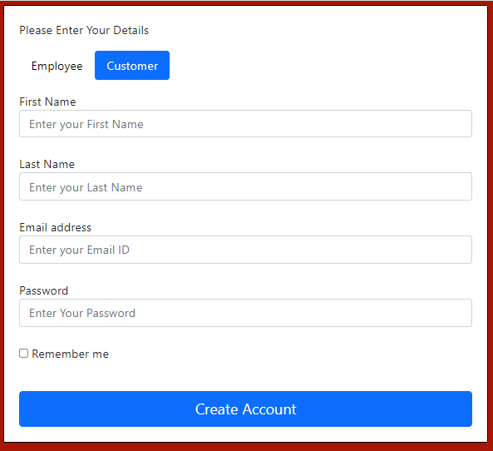

Figure : Customer Sign Up page

|  |  |  |  |  |  |  |
| --- | --- | --- | --- | --- | --- | --- |
| Label | Description | Value | Format | Type | Size | Required |
| First name | A text value entered by user | User Input | Text | Characters | 15 Bytes | Yes |
| Last Name | A text value entered by user | User Input | Text | Characters | 15 Bytes | Yes |
| Email Address | A unique text value entered by user | User Input | Text | Characters | 50 Bytes | Yes |
| Password | A value given to each corresponding username | User input | Text | Characters | 15 Bytes | Yes |

Table 1: Customer Sign up fields table

1. Employee Sign Up Page: which leads employee to Sign Up page shown in “Figure 7”, that will allow to create an account with ShipSmart software, by filling out the required fields, the below table “Table 2” describes these fields:

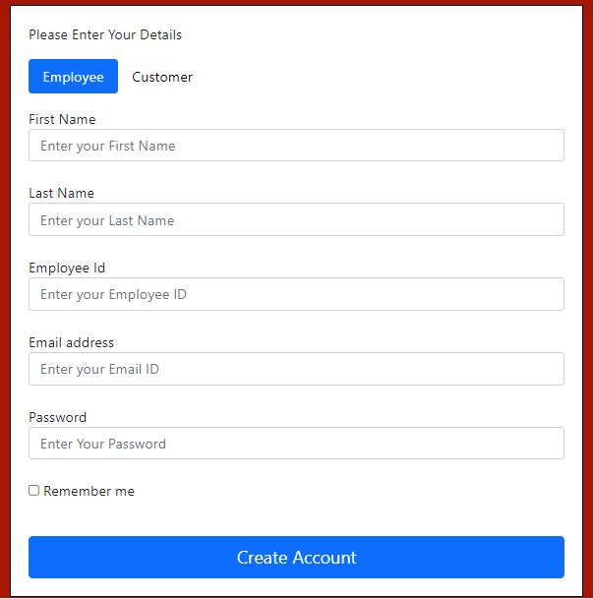

Figure : Employee Sign Up page

|  |  |  |  |  |  |  |
| --- | --- | --- | --- | --- | --- | --- |
| Label | Description | Value | Format | Type | Size | Required |
| First name | A text value entered by user | User Input | Text | Characters | 15 Bytes | Yes |
| Last Name | A text value entered by user | User Input | Text | Characters | 15 Bytes | Yes |
| Employee Id | A unique number value entered by user | User Input | Number | Integer | 15 Bytes | yes |
| Email Address | A unique text value entered by user | User Input | Text | Characters | 50 Bytes | Yes |
| Password | A value given to each corresponding username | User input | Text | Characters | 15 Bytes | Yes |

Table 2: Employee Sign Up fields Table

# **7. Login Page**

* Customers and employees with pre-set username and password, will be able to login to ShipSmart Software.
* After a successful login, a logout link will appear at the right top corner of each page of the software.
* The login box will contain the following:
* Log-in **fields**, the below table describes these fields:
* A **forgot password** check box.

|  |  |  |  |  |  |  |
| --- | --- | --- | --- | --- | --- | --- |
| Label | Description | Value | Format | Type | Size | Required |
| Username | A unique value given to each officer | User Input | Text | Characters | 50 Bytes | Yes |
| Password | A unique value given to each corresponding username | User input | Text | Characters | 10 Bytes | Yes |

Table3: Employee Login Fields Table

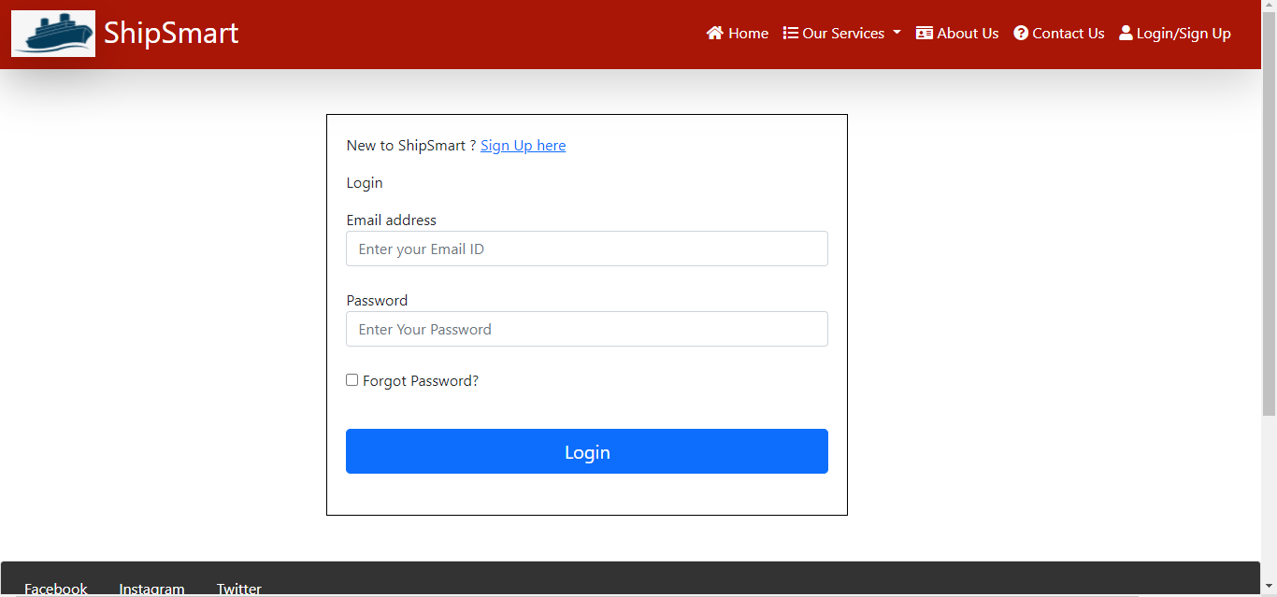

*Figure 8: Login form*

|  |  |  |  |
| --- | --- | --- | --- |
| **Use Case Definition** | | | |
| **Actors** | | User | |
| **Description** | | Allows the users to Login. | |
| **Preconditions** | | Actor must enter the website URL on a supported device browser. | |
| Main Flow | | | |
| No. | Actor Action | | System Response |
|  | Actor clicks on login tab in the main page. | | * ShipSmart software will open a page for user to enter login credentials. |
|  | Actor enters the email address and the password which includes digits and letters. | | * ShipSmart Software will forward the user to the Home page. |
| Alternative Flow | | | |
| None | | | |
| Exceptional Flow | | | |
| None | | | |
| Post Conditions | | | |
| None | | | |

Table : Customers Login Use Case definition

## **7.1 Customers’ Login/ Sign up Sequence Diagram**

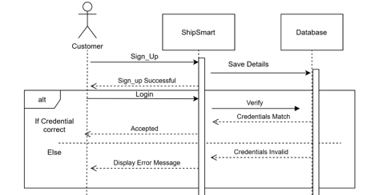

Figure : Customer Sequence Diagram

|  |  |  |  |
| --- | --- | --- | --- |
| **Use Case Definition** | | | |
| **Actors** | | User | |
| **Description** | | Allows the users to Login. | |
| **Preconditions** | | Actor must enter the website URL on a supported device browser. | |
| Main Flow | | | |
| No. | Actor Action | | System Response |
|  | Actor clicks on login tab in the main page. | | * ShipSmart software will open a page for user to enter login credentials. |
|  | Actor enters the email address and the password which includes digits and letters. | | * ShipSmart Software will forward the user to the Home page. |
| Alternative Flow | | | |
| None | | | |
| Exceptional Flow | | | |
| None | | | |
| Post Conditions | | | |
| None | | | |

Table : Employee login use case definition

## **7.2 Employee Login/ Sign Up Sequence Diagram:**

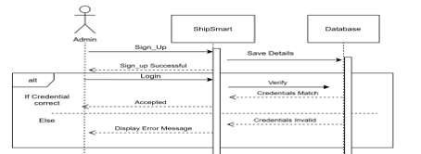

Figure : Employee login/ sign up Sequence Diagram

# **8. Create Shipment**

Once the user logged in, user will get an option for create shipment. “Create shipment” option will be available as dropdown item in “Our Services” navigation bar shown in Figure 11

## **8.1 Create Tab**

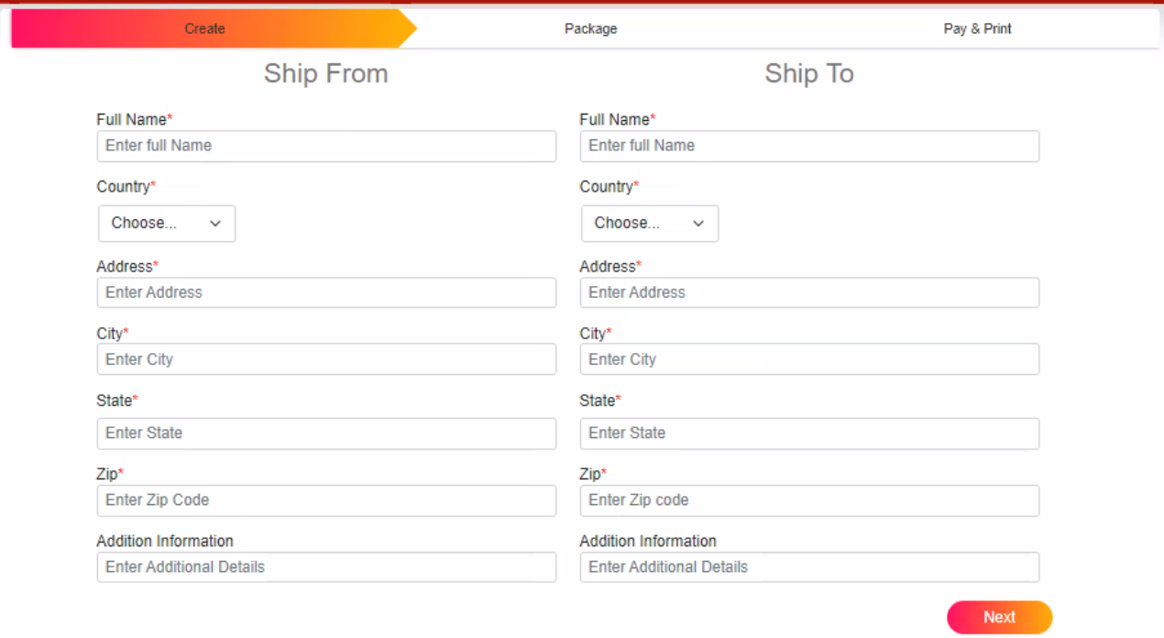

Figure : Create Shipment Form

|  |  |  |  |  |  |  |
| --- | --- | --- | --- | --- | --- | --- |
| Label | Description | Value | Format | Type | Size | Required |
| Full Name | A text value entered by user | User Input | Text | Characters | 100 Bytes | Yes |
| Country | A text value selected by user from a drop menu | User input | Text | Characters | 100 Bytes | Yes |
| Address | A text value entered by user | User input | Text | Characters | 100 Bytes | Yes |
| City | A text value entered by user | User input | Text | Characters | 100 Bytes | Yes |
| State | A text value entered by user | User input | Text | Characters | 100 Bytes | Yes |
| Zip code | A number value entered by user | User input | Number | Integer | 10 Bytes | Yes |
| Additional Information | A text value entered by user | User input | Text | Characters | 200 Bytes | No |

Table : Shipping from Required Fields

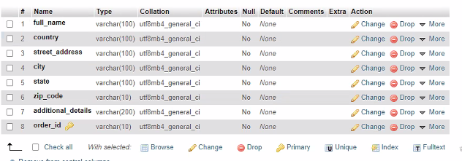



Figure Database of Create Shipment

## **8.2 Package Tab**

Click on the next button then enter the required fields of package information as shown in Figure 12

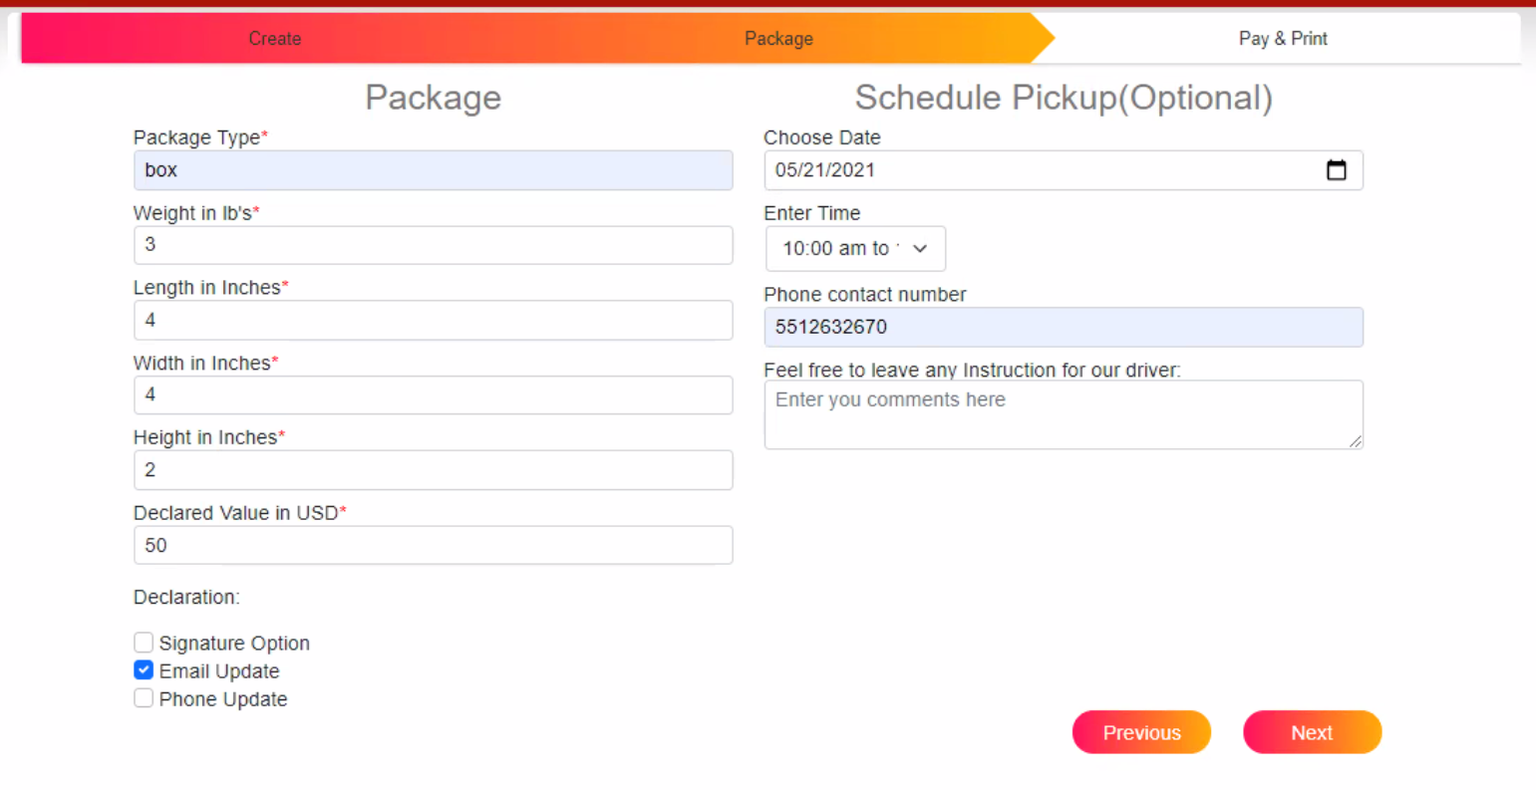

Figure : Create Shipment Package Information

|  |  |  |  |  |  |  |
| --- | --- | --- | --- | --- | --- | --- |
| Label | Description | Value | Format | Type | Size | Required |
| Package Type | A text value entered by user | User Input | Text | Characters | 50 Bytes | Yes |
| Weight in lb’s | A number value entered by user | User input | Text | float |  | Yes |
| Width in inches | A number value entered by user | User input | Text | float |  | Yes |
| Height in Inches | A number value entered by user | User input | Text | float |  | Yes |
| Declared value in USD | A value entered by user | User input | Text | Characters | 50 Bytes | Yes |
| Signiture Option | A check box can be selected by user | User input | True/ false | Boolean | 1 Bytes | No |
| Email Update | A check box can be selected by user | User input | True/ false | Boolean | 1 Bytes | No |
| Phone Update | A check box can be selected by user | User input | True/ false | Boolean | 1 Bytes | No |
| Pick Up Date | A date value selected by user | User input | Text | Date |  | Yes |
| Pick Up Time | A text value selected by user | User input | Text | Characters | 20 Bytes | Yes |
| Phone Number | A number value entered by user | User input | Text | Characters | 30 Bytes | Yes |
| Driver Instruction | A text value selected by user | User input | Text | Characters | 200 Bytes | No |

Table : Package Details Section Required Fields

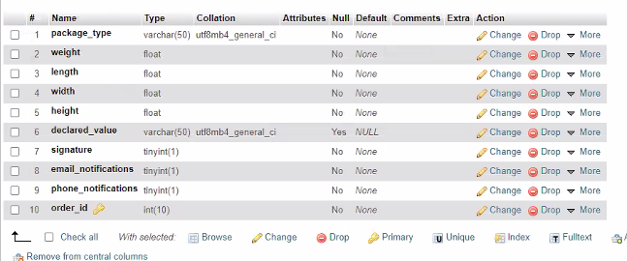



Figure : Database of Package Information

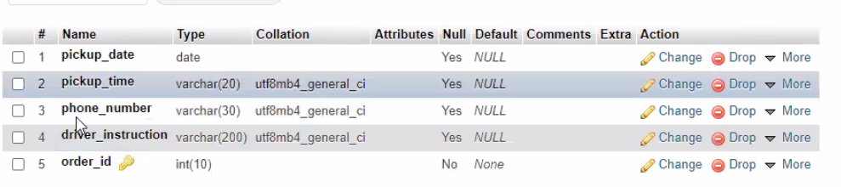



Figure Database of Schedule Pickup

## **8.3 Pay & Print Tab**

Once the user clicks on the next, it will navigate to payment pages. It gives an option for entering coupons and selecting shipment options. The payment options and the coupons can be con Figured in the database. Customer has to enter all the required fields in order to proceed to checkout.

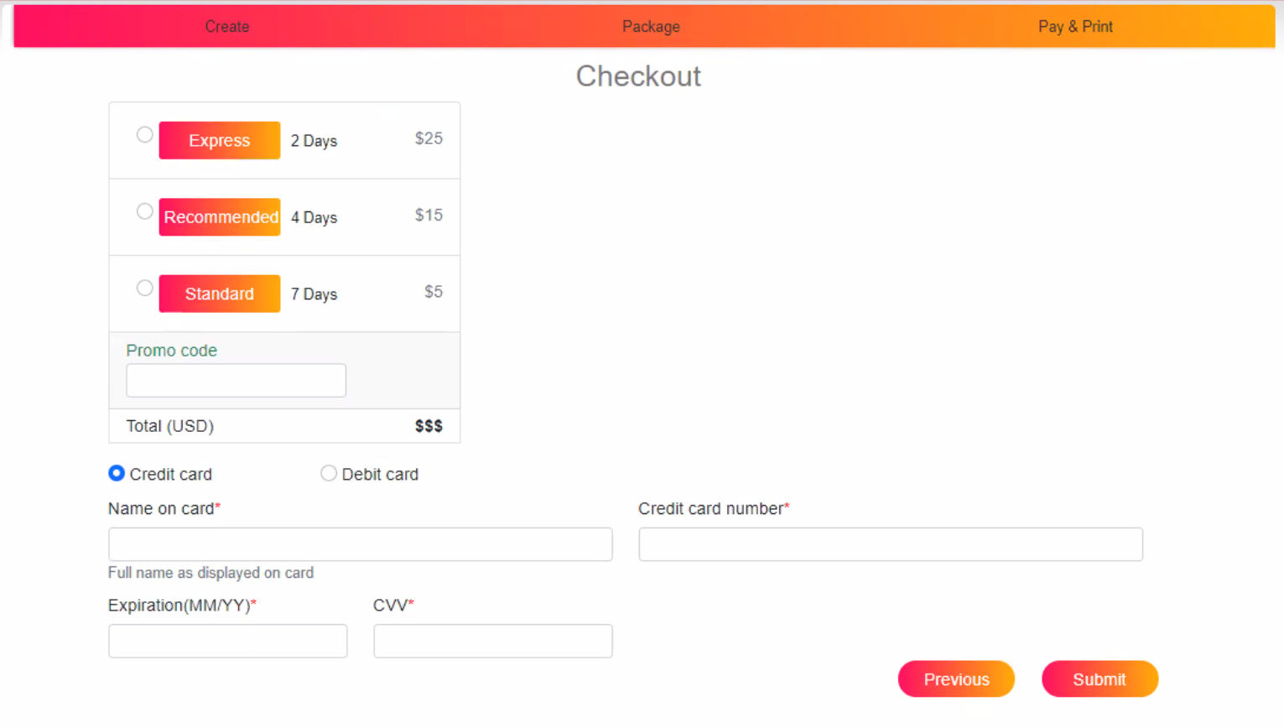

Figure : Payment Section of Create Shipment

|  |  |  |  |  |  |  |
| --- | --- | --- | --- | --- | --- | --- |
| Label | Description | Value | Format | Type | Size | Required |
| Express Shipping | Radio Button can be selected by the user | User Input | Text | Characters | 1 Bytes | Yes |
| Recommeded Shipping | Radio Button can be selected by the user | User input | Text | Characters | 1 Bytes | Yes |
| Standard Shipping | Radio Button can be selected by the user | User input | Text | Characters | 1 Bytes | Yes |
| Promo Code | A text value entered by user | User input | Text | Characters | 50 Bytes | Yes |
| Credit Card | Radio Button can be selected by the user | User input | Text | Boolean | 1 Bytes | Yes |
| Debit Card | Radio Button can be selected by the user | User input | Number | Boolean | 1 Bytes | Yes |
| Name on the Card | A text value entered by user | User input | Text | Characters | 100 Bytes | yes |
| Credit Card Number | A value entered by user | User input | Number | Integer | 100 Bytes | yes |
| Expiration Date | A text value entered by user | User input | Text | Characters | 100 Bytes | yes |
| CVV | A three digits number entered by the user | User input | Number | Integer | 3 Bytes | yes |
| Delivery Date | A date shown by the ShipSmart Software | System  Returned Value | Text | Characters | 100 Bytes | yes |
| Delivery Time | A date shown by the ShipSmart Software | System  Returned Value | Text | Characters | 100 Bytes | yes |
| Total Amount | A number shown by the ShipSmart Software | System  Returned Value | Number | Float | 100 Bytes | yes |

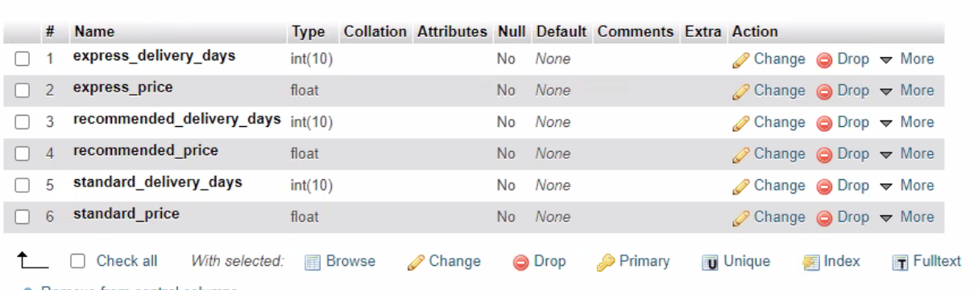

Figure : Database of Delivery Options

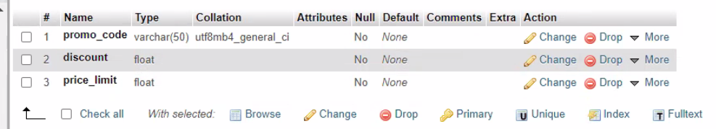

Figure : Database of Promo Code

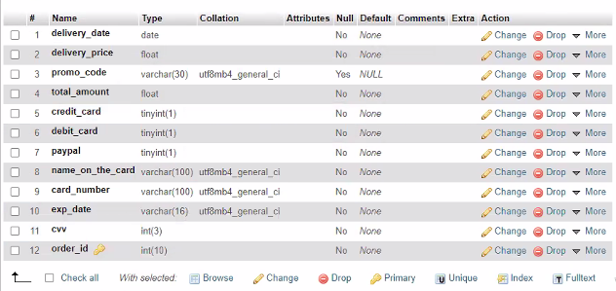

Figure : Database of Payment Section

Once all the mandatory information is entered user can click on submit button to submit the form. It also provides option for navigate back using previous button. On submission, it will direct the user to the confirmation page, it will provide dynamically created tracking information with the unique Tracking Id. ShipSmart system will send an email to the customer with the related tracking information for his placed order.

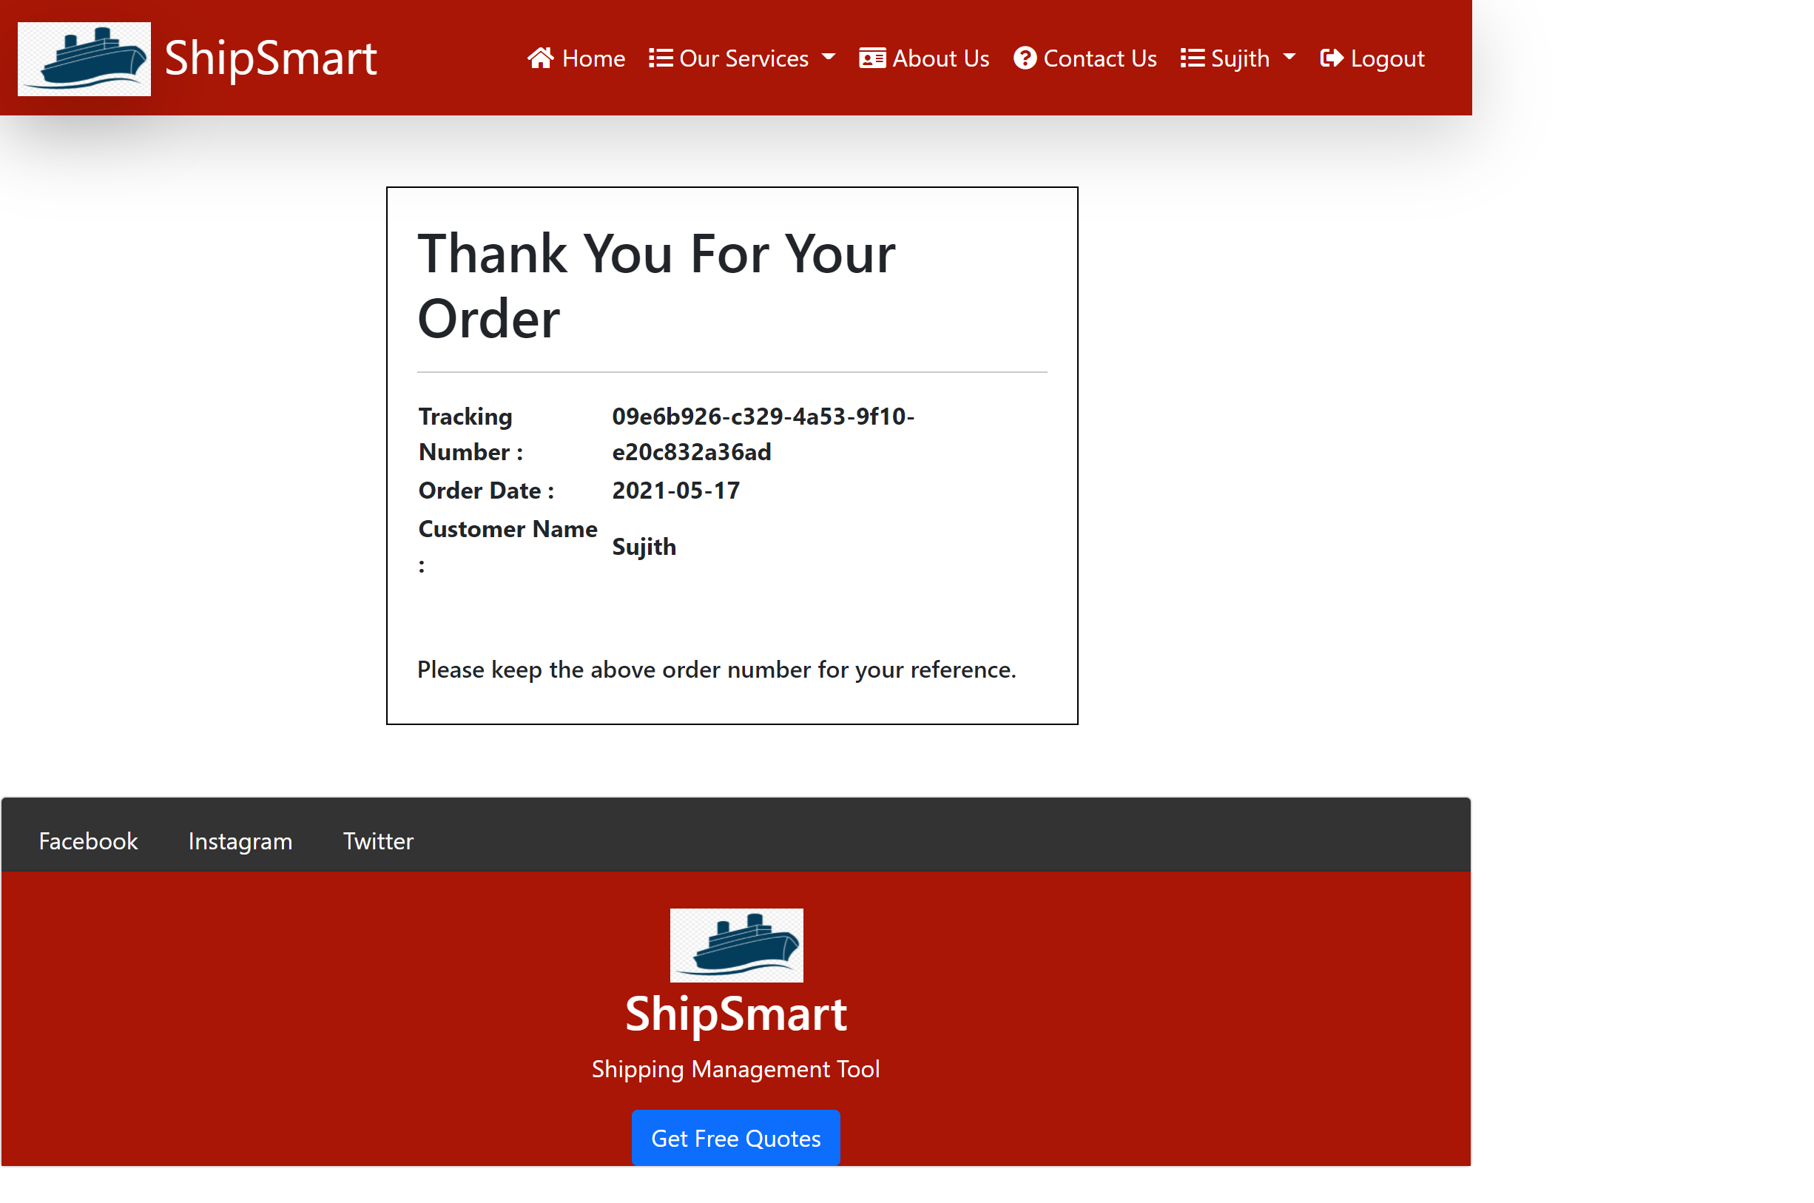

Figure : Order Confirmation

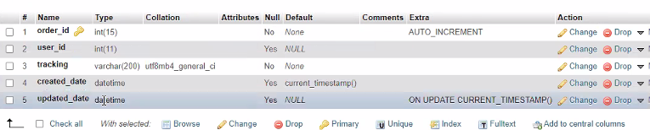



Figure : Database of Order Confirmation

## **8.1. Sequence diagram of Create shipment/ make payment**

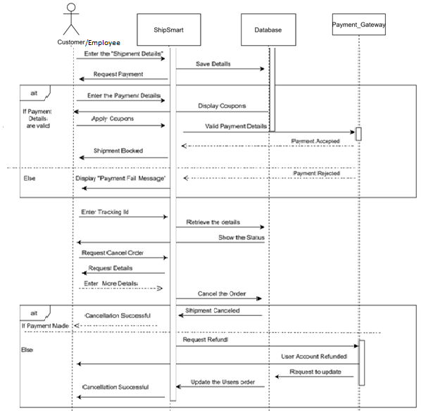

Figure :create shipment/ make payment sequence diagram

# **9. Track shipment Use Case Definition.**

|  |  |  |  |
| --- | --- | --- | --- |
| **Use Case Definition** | | | |
| **Actors** | | User | |
| **Description** | | Allows the users to track their shipments | |
| **Preconditions** | | Actor must enter the website URL on a supported device browser. | |
| Main Flow | | | |
| No. | Actor Action | | System Response |
|  | Actor clicks on Track Shipment Button in the main page. | | * ShipSmart software will open a form for user to enter shipment tracking number. |
|  | Actor enters the tracking number which includes digits and letters. | | * ShipSmart Software will retrieve a message for the user including the last place of the shipment. |
| Alternative Flow | | | |
| None | | | |
| Exceptional Flow | | | |
| None | | | |
| Post Conditions | | | |
| None | | | |

Table 4: Track Shipment Use Case

# **10. International Shipping Page**

The International page design will be as follows:

* As of all pages/screens on the ShipSmart software this page must follow the unified pages look specified in section 4.
* Between the page’s header and footer, the page will display a paragraph of the title “History” and a text paragraph that reflects user specified content.



Figure : International Shipping

# **11. Delivery Rates**

User Can check and compare the international delivery rates from “our services” option in the nav bar.

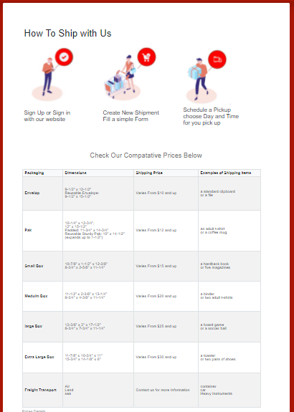

Figure Delivery Rates

# **12. About US**

Clicking on the About Us option in the navigation bar will direct the user to the about us page; which has description about the PATCO company as shown Figure 18 below.

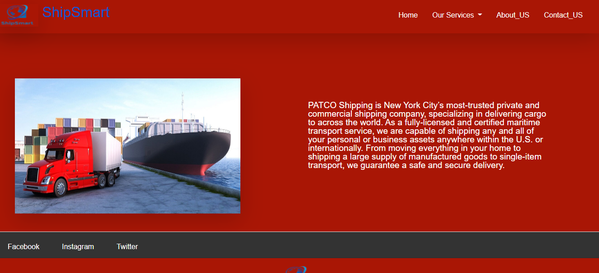

Figure : About Us

# **13. Contact Us**

Clicking on Contact Us option will navigate the users to the Contact Us page as shown Figure 19 below. User will be able to view PATCO contact information as well as user can send message by entering the Name, Email address, Phone Number and the Message to PATCO email via Contact Us page.

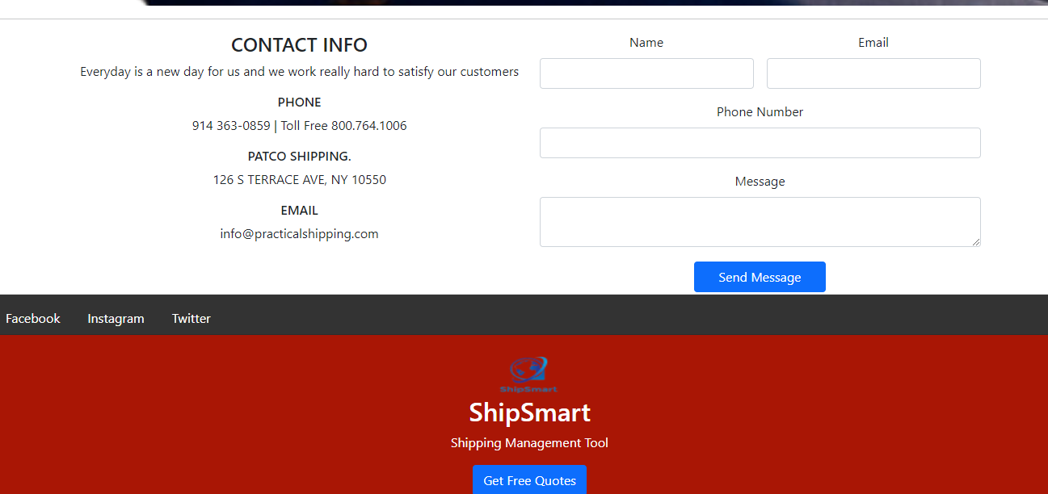

Figure : Contact Us

# **14. Admin Dashboard**

Admin dashboard will give all the orders details with the created date. Clicking on the order ID will direct the employee to order information page as show in Figure 20 and Figure 21.

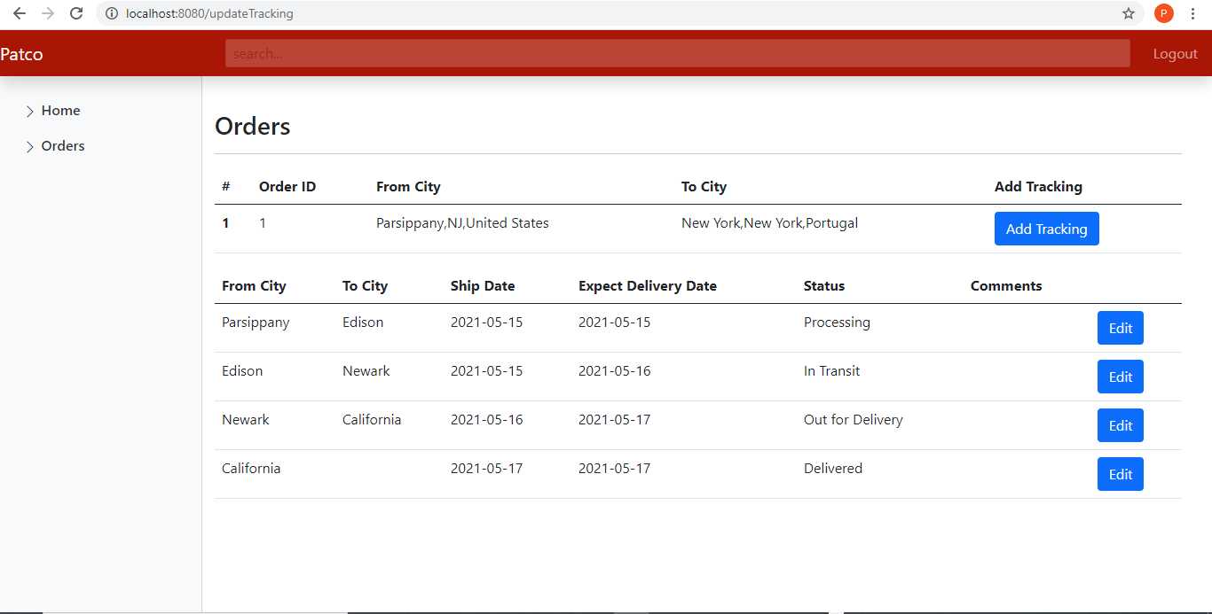

Figure : Admin Dashboard

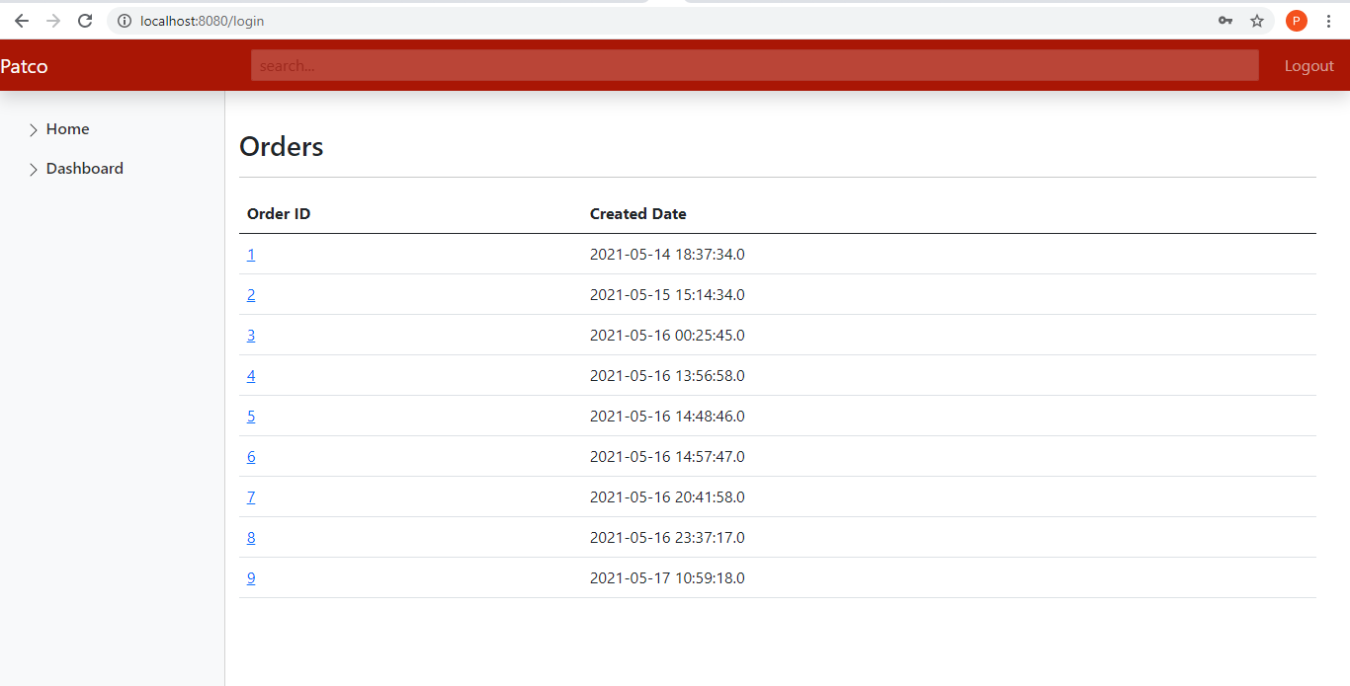

Figure : Customer Order History